# 

# 

# 

# 

# ApartMate

Team 3

Group members - Adrian Raj, Akshay Srinivasan, Ian Rettig, Risheek Narayanadeverekere, Siddhant Patel

## Design Document

### Index

* Purpose 3
* Design Outline 4
  + Components
  + High-Level Overview
  + State/Activity Diagram
* Design Issues 6
  + Functional Requirements
  + Non-Functional Requirements
* Design Detail 9
  + Data Classes Diagram
  + Data Classes Description

### 

### 

### Purpose

People moving to a new location and searching for an apartment need a place to go to find roommates to live with in an apartment. This app idea has been done a lot, so we decided to add more features to it. We also have a part of the app that is used after roommates are found. This part is intended for use throughout the time that the roommates live together in the apartment. Some features of that part include a group chat, schedules, chore lists with reminders, a bill splitter, and a shopping list with location based notifications. These features exist in an app already on the market, Roof, but this app has unfavorable reviews on the android market, mainly due to bugs in the system.

We intend to be a better choice than Roof by providing a bug free experience with a few additional features that that app does not have. On the other hand, we intend to be a better market for users searching than the other apps by having these extra features. Another additional feature that comes from the long nature of our app is ratings for individual users. This feature is intended to help with the future of an individual’s roommate search. Having these two parts together in one location makes our app the best choice when it comes to finding a roommate.

### Design Outline

### 

### High Level Overview

### 

The project will be a cross-platform Web Application, Android app, and iOS app that aims to have a clean, focused platform for all the needs of living in an apartment such as splitting bills, assigning chores, knowing each other’s schedule, and having a grocery list along with a messaging feature. The application will follow a client-server architecture in which the server will be able to satisfy requests from multiple clients, query the database, and respond to the client with all the necessary information.

### 

1. Client
   1. Provides a user interface for the user to interact with the backend.
   2. Sends XMLHttpRequests or AJAX requests to the server.
   3. Processes the response received from the server and updates the UI accordingly.
2. Server
   1. Receives, validates, and handles XMLHttpRequests or AJAX requests from the clients
   2. Queries the database for information and modifies the data stored if needed.
   3. Responds to the client with the appropriate information.
3. Database
   1. Firebase Cloud Firestore stores all the application data and user information.
   2. Responds to queries to gather or modify data and sends the information back to the server.

### Activity/ State Diagram

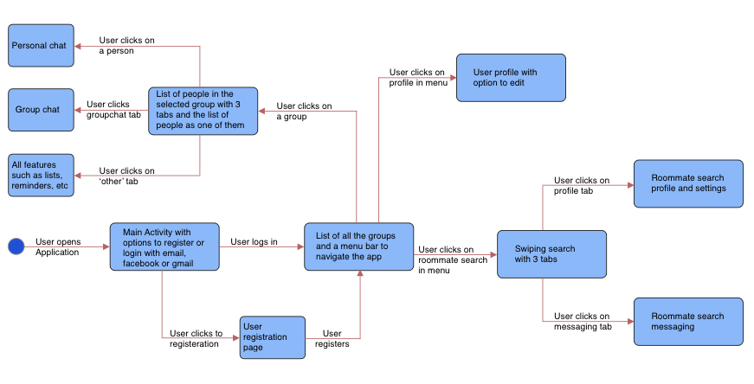

### Design Issues

#### Functional Issues

#### What information do we need for signing up

1: username and password

**2: email, password**

3: username, password, email, phone number

We decided to use email and password to sign up new users because we learned from reviews from the currently existing apps that the users did not like to share a lot of information with these apps and services, so that ruled out the third option for us. When comparing the first and the second options it made more sense for us to sign up a new user with their email so that we could have that on record as a means to communicate account-related information with them while having a way to validate the user. We did not consider it necessary to ask for a real name while signing up for the app however, they would be required to provide their name for the roommate search. For the sake of sign up simplicity, we decided that at sign up all the information we needed from the user was email and password.

#### How do we acquire the location of the user and when is it used?

**1: manual input**

**2: GPS**

We decided to use both manual input and GPS for location services. This is because there are two different features that you can use that are used in different contexts. One of these features is the location for where a user is looking for an apartment in a certain location. We do not want to use GPS for this feature due to the possibility of a user looking for an apartment in an area that is different from where they currently are. To solve that issue, we will have the ability to choose where to search for roommates. The second feature is the location based notifications for objects that are on the shopping list. This requires live location data, so GPS is the best option for it.

#### 

#### 

#### How do we allow users to chat with each other

**1: instant messaging**

2: real-time chat room

Due to one of the main focuses of the app being communication between its members, messaging is a concern. Instant messaging has a lot in common with a real-time chat room, however, you need to be in the chat room to receive these messages. We want the messages accessible at all times, so a user does not need to enter and leave a room. This is achieved by having instant messaging and storing the messages on a server, and possibly having them also stored locally to view while out of connection.

#### Non-Functional Issues

#### Deciding what framework to use

### **1: NativeScript**

### 2: React

Once we settled on an idea for our project, we needed to decide upon a framework to build it on. Teammates suggested a couple of frameworks- NativeScript and React. We considered React until we realised that NativeScript was cross-platform- android, iOS and web. It is also easily extensible and allows to use existing plugins from npm, CocoaPods (iOS), and Gradle (Android).

### 

#### What database system to use

1: MySQL

2: MongoDB

**3: FireBase**

We were initially deliberating over the choice of our database but once the specifics of our project sinked in, FireBase was the obvious pick. It is cloud based which serves our purpose perfectly and hence the choice. Firebase provides certain algorithms that might prove useful. It also provides facebook and google login methods. Firebase also allows us, as maintainers to disable certain users for malpractice.

What API to use for location data

**1: Google Maps API**

2: HTML Geolocation API

The HTML Geolocation API is obsolete and not used very often anymore. The Google Map API on the other hand is much more widely used, and is less intrusive about the data used to obtain the location. Google Maps API uses the wifi and cell tower data to find location whereas the HTML Geolocation API hands over control of the internet and physical inputs to the device in order to find the location.

### Design Details

This sequence diagram shows the sequence of events when user wants to check his profile.

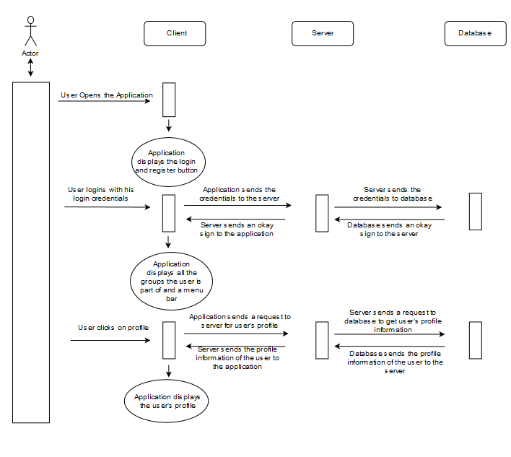

This sequence diagram shows the sequence of events when user wants to chat with a certain group the user is part of.

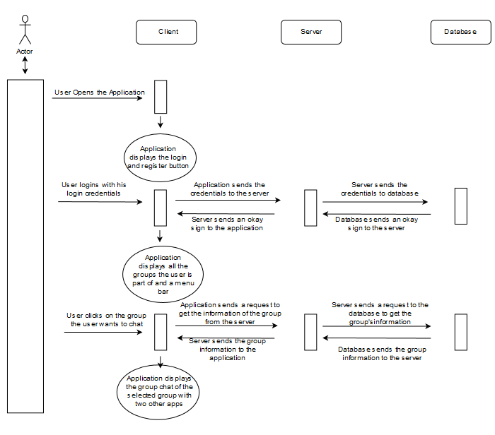

This sequence diagram shows the sequence of events when user wants to see potential roommates.

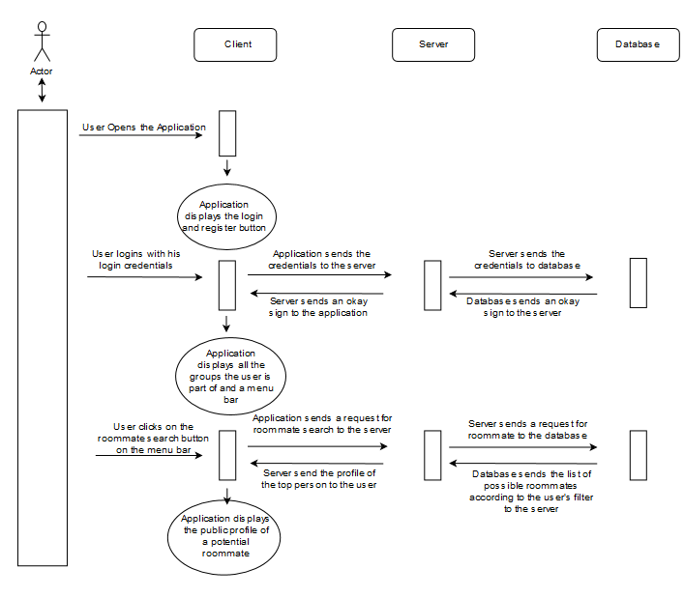

### Class Level Diagram

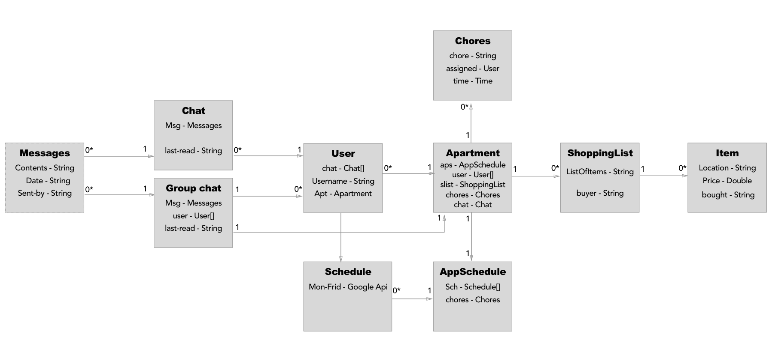

### 

### Description of Classes

* Messages
  + Each message will have the content of the message which will be of the type String
  + Each message will have the date and time
  + Each message will show who sent it
* Chat
  + Each chat will have list of Messages
  + Each chat will have the user
  + Each chat will show the last-read by User
* GroupChat
  + Each GroupChat will have list of Messages
  + Each GroupChat will have a list of Users
  + Each GroupChat will show the last-read by Users
* User
  + Each User has a group of Chats
  + Each User has a username
* Schedule
  + The scheduling will be done using the Google API.
* Chores
  + Each Chore has a string that contains what the chore is.
  + Each Chore has a assigned which tells us which user it is assigned to.
  + Each Chore has a time when the app sends a notification to the assigned person.
* Apartment
  + This is the overarching class for the apartment
  + Contains the apartment schedule, list of users, shopping list, chores, and group chat
* AppSchedule
  + Linked to the user’s schedule to make an overarching schedule
  + Obtains chore information from the apartment in order to add the chores to the schedule
* Shopping List
  + Each shopping list has a list of items which is a string.
  + Each shopping list has a buyer which is of type string.
* Item
  + Each item has a location using Google Maps
  + Each item has a price which will be of int type.

### UI Mockups

Home page - Users can login through their email, Facebook, Twitter or Google. Or they can register as new Users

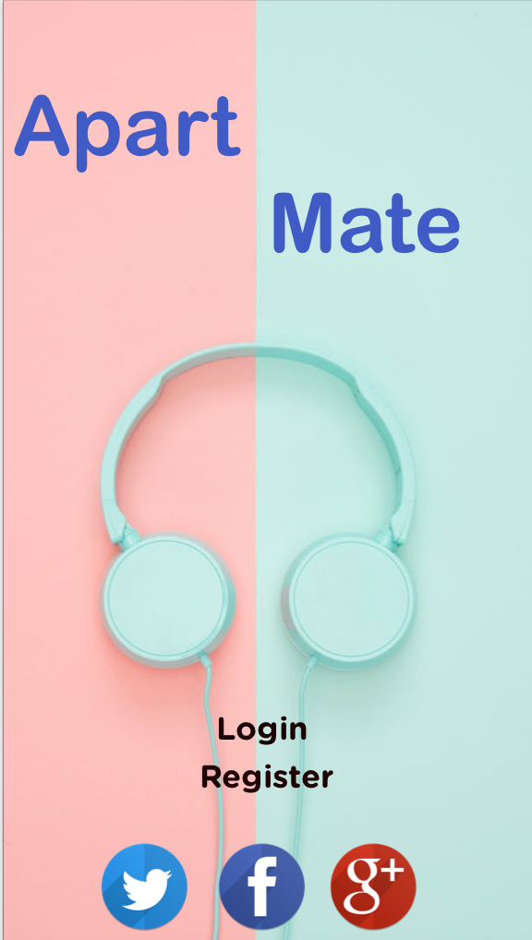

Login Page - Users can login through their email and password

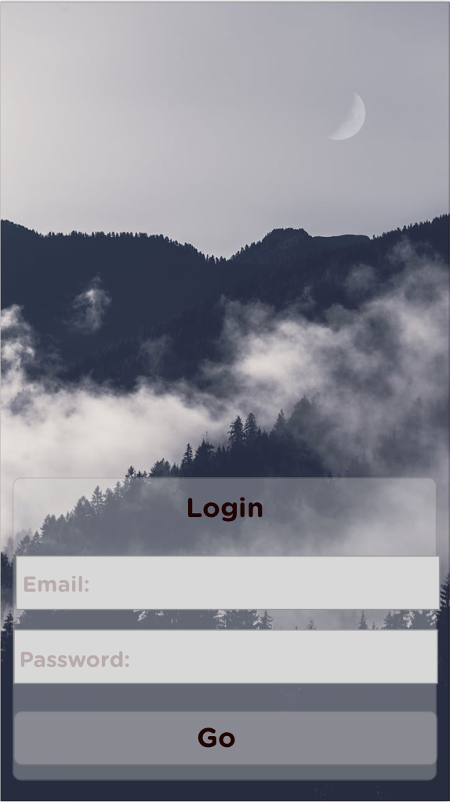

Register Page - Users can register through this page

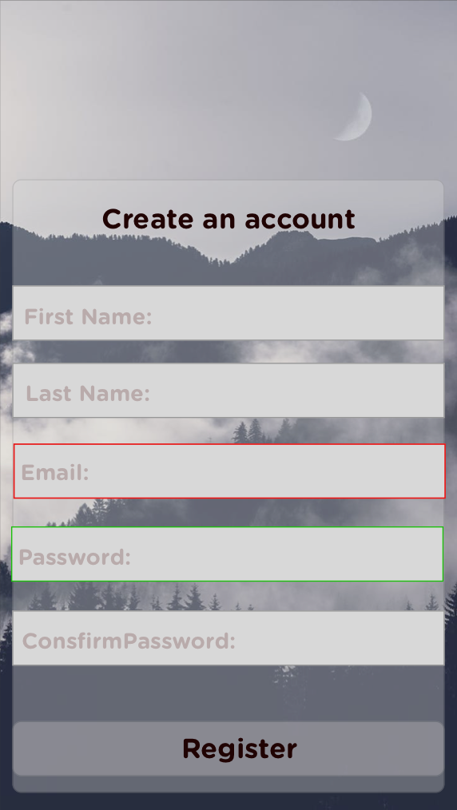

Message Page - Users can see their group messages

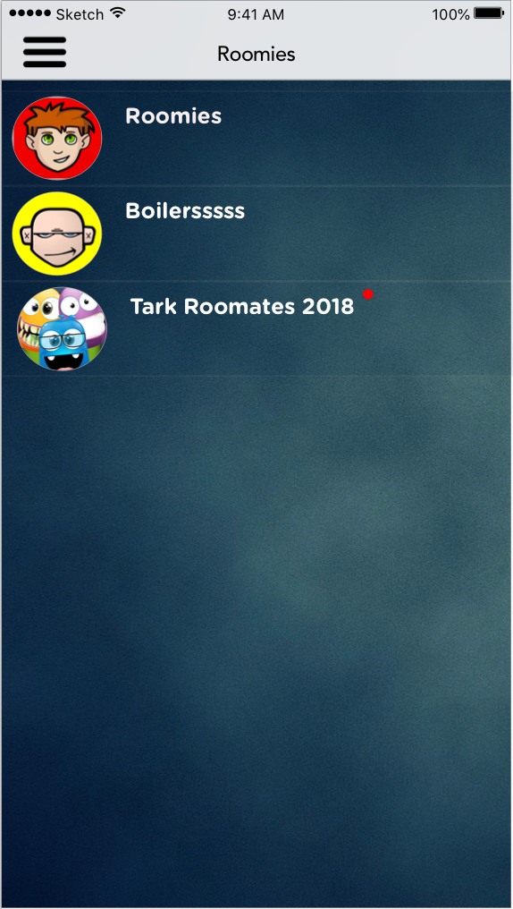

Chat Page - Users can chat with each other in a group

